### **How to install SketchUp 2016 in Ubuntu 15.10 amd64**

<http://hrvooje.blogspot.com/2015/11/how-to-install-sketchup-2016-in-ubuntu.html>

I would like to show you how I installed SketchUp 2016 in Ubutun 15.10 x64. My laptop has Intel integrated video card and runs Ubutnu 15.10 x64.  
  
First thing first, install wine.   
  
*sudo apt-get install wine*  
  
I am using wine-1.6.2. To find out which wine version you have, type:  
  
*wine --version*

[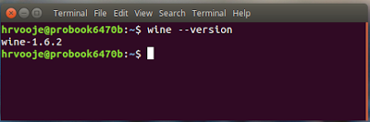](http://1.bp.blogspot.com/-56lkHh9sH3k/VlbBivma_qI/AAAAAAAALXs/4DXzntdEBV8/s1600/Screenshot+from+2015-11-26+09-23-12.png)

After installing wine, we should configure it by running in terminal:

*winecfg*

In Wine Configuration window in Applications tab, change Windows Version to Windows 7 and in Libraries tab find riched20 library and add it.

[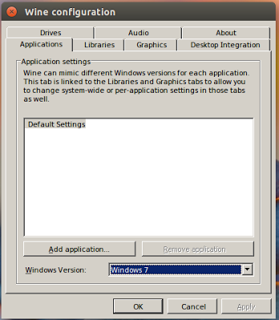](http://4.bp.blogspot.com/-0W4M1JV7smg/VlbGLmuJccI/AAAAAAAALX8/6RI1UVaYpv8/s1600/Screenshot+from+2015-11-26+09-38-00.png)

[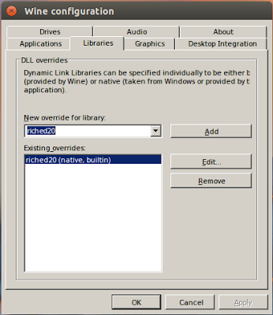](http://2.bp.blogspot.com/-67gMEDam_P0/VlbGUv7HI0I/AAAAAAAALYE/iLvFoi8xcko/s1600/Screenshot+from+2015-11-26+09-42-50.png)

Than download SketchUp 2016 for Windows from [here](http://www.sketchup.com/) and run installer using wine. You can do this by just double clicking the installer or right click on it and choose *Open With Wine..*and follow the install wizard.

[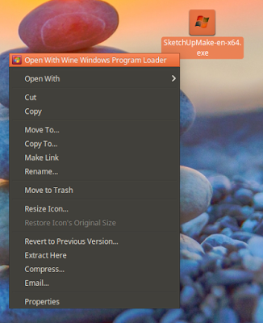](http://2.bp.blogspot.com/-wRqBzcF2XBg/VlbHQe1F3KI/AAAAAAAALYM/Ftirf6sDCPM/s1600/Screenshot+from+2015-11-26+09-31-47.png)

Now you should be able to see SketchUp shortcut icons on your desktop. Right click on SketchUp 2016 icon, select Propertis and under Command input filed enter at the end */DisableRubyAPI*

[](http://3.bp.blogspot.com/-9nekDDXysQc/VlbI10rRIAI/AAAAAAAALYU/Q9iB2krSBIg/s1600/Screenshot+from+2015-11-26+09-52-04.png)

Just one more thing. Download mfc100u.dll library frome [here](https://drive.google.com/file/d/0B67ZDYW07PDuMXc2OFY5MUg2aW8/view?usp=sharing), and copy it in system32 wine folder. To go there press ctrl+H in Nautilus to see hiden folders in your home folder and navigate to .wine/drive_c/windows/system32/ and copy it there.

If you can't save your SketchUp project, try changing in Wine configuration after installation to Windows XP version like suggested in comments by Dan Helios. Thanks Dan!

Enjoy!

[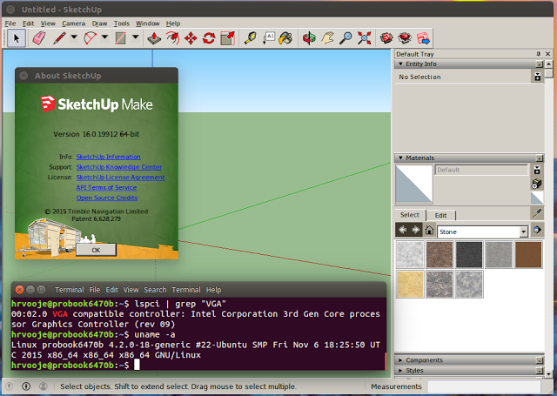](http://1.bp.blogspot.com/-u8hcyvAXiOo/VlbLiv1VhQI/AAAAAAAALYg/a2fJsndSQ20/s1600/Screenshot+from+2015-11-26+10-06-01.png)